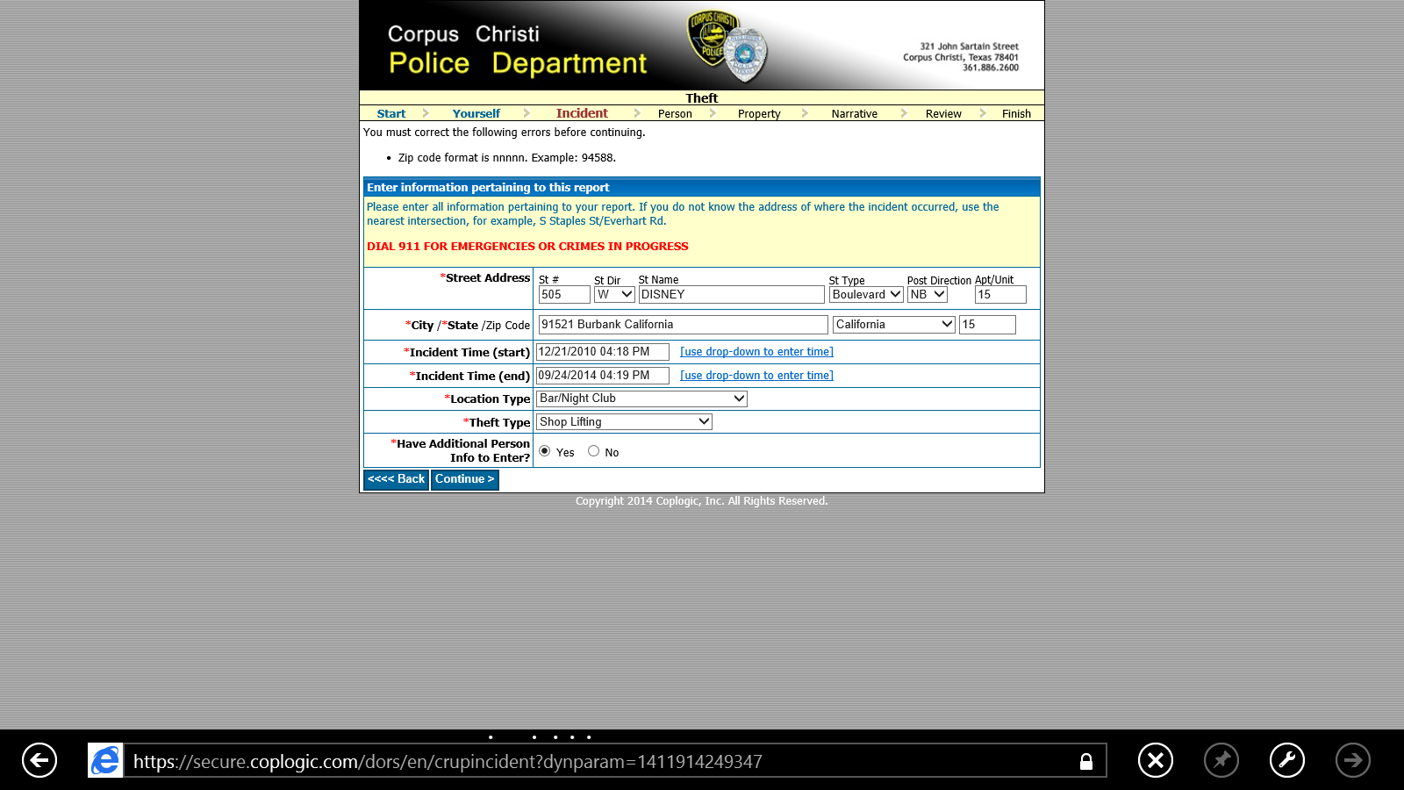
CORPUS CHRISTI POLICE DEPARTMENT 321 JOHN SARTAIN STREET CORPUS CHRISTI, TEXAS 78401
(3618862600) Corpus Christi Police Department,
Unfortunately, i cannot to until do the process on your website.
I deposit a complaint against Rick Riordan american author at Disney house publishing in Los Angeles at Burbank California. Between one and doesn’t thunders, his car destroyed myself. OH NEW YEAH HEAD !!! and you'll be a winner ! poor men !GOOD FORTUNE WITH YOUR ASSGOOD JOB YOU ARE BUT STUPID YOU STAY ». THREE YEARS AGO I RECEIVED A QUERY BY WWE STAMFORD CONNECTICUT HEADQUARTERS. WE PROMISED ME A JOB INSIDE WWE THE QUERY DATING OF JANUARY 28, 2011. I WAIT ONE YEAR AFTER I EVER RECEIVE ANY NEWS OR ANSWER ABOUT THE PROMISE BY WWE. IN JULY 2012 FEW WRESTLERS INCLUDING JOHN CENA AND DWAYNE JOHNSON COMING WHERE I LEAVE IN MY APARTMENT IN VICHY TOWN IN FRANCE COUNTRY TO REACH ME PERSONAL INJURY AND FREE HUMILIATIONS TO INDICATE BETTER THAN ONE YEAR AFTER THE PROMISE BY WWE THAT I WAS UNABLE FOR WRESTLING OR ANY FIGHT INSIDE JOB COMPANY. I CLAIM TODAY MY RIGHTS ON A QUERY THAN THE WHITE HOUSE AT WASHINGTON D.C. GUARD IN SECRET. COULD YOU CALL THE WHITE HOUSE AT 202 456 1414 IN SWITCHBOARD FOR ME ??? THEM SAVED. I LEAVE RIGHT AWAY IN UNITED STATES. Rick Riordan take the control in 2012 when the coming actress from Hollywood negotiating with WWE apparently for business. She coming girls and others colleagues for my works in violations by catastrophic injury against me. Cameron Diaz serves Angelina Jolie investigations. I guarantee it at FBI headquarters from Washington D.C. they get a file about to be like it. I deposit a complaint against Rick Riordan for catastrophic injury and claim one million dollars on compensations. She destroyed my dreams with signing promises by WWE contracts. Every single conflict. She told me : « YOU REMEMBER ME THEM TRAUMA BANDIT BUCK PRODUCTIONS. SPECIAL BAD BLACK BOY. No drop. Don't drink and don't smoke on the client account ! BASTARD !! Richard Bouskila

